1. Candy

There are *N* children standing in a line. Each child is assigned a rating value.

You are giving candies to these children subjected to the following requirements:

* Each child must have at least one candy.
* Children with a higher rating get more candies than their neighbors.

What is the minimum candies you must give?

**Example 1:**

Input: [1,0,2]  
Output: 5  
Explanation: You can allocate to the first, second and third child with 2, 1, 2 candies respectively.

**Example 2:**

Input: [1,2,2]  
Output: 4  
Explanation: You can allocate to the first, second and third child with 1, 2, 1 candies respectively.  
 The third child gets 1 candy because it satisfies the above two conditions.

**解法1** 暴力求解

不断循环，调整分配，直到收敛

*java不超时，cpp出现超时。。。*

public class Solution {  
 public int candy(int[] ratings) {  
 int[] candies = new int[ratings.length];  
 Arrays.fill(candies, 1);  
 boolean flag = true;  
 int sum = 0;  
 while (flag) {  
 flag = false;  
 for (int i = 0; i < ratings.length; i++) {  
 if (i != ratings.length - 1 && ratings[i] > ratings[i + 1] && candies[i] <= candies[i + 1]) {  
 candies[i] = candies[i + 1] + 1;  
 flag = true;  
 }  
 if (i > 0 && ratings[i] > ratings[i - 1] && candies[i] <= candies[i - 1]) {  
 candies[i] = candies[i - 1] + 1;  
 flag = true;  
 }  
 }  
 }  
 for (int candy : candies) {  
 sum += candy;  
 }  
 return sum;  
 }  
}

**解法2** 使用两个数组l2r, r2l，分别表示与左边满足要求时的分配和与右边满足要求时的分配

从右往左扫描r2l：

if ratings[i] > ratings[i-1] && r2l[i] <= r2l[i-1] : r2l[i] = r2l[i-1] + 1

从左往右扫描l2r：

if ratings[i] > ratings[i+1] && r2l[i] <= r2l[i+1] : r2l[i] = r2l[i+1] + 1

最终 $res=\sum_{i=0}^{n−1}{\text{max}}\{l2r[i],r2l[i]\}$

class Solution {  
public:  
 int candy(vector<int>& ratings) {  
 int n = ratings.size();  
 if(n == 1) return 1;  
   
 vector<int>l2r(n, 1), r2l(n, 1);  
 for(int i = 1; i < n; ++i){  
 if(ratings[i] > ratings[i-1])l2r[i] = l2r[i-1] + 1;  
 }  
 for(int i = n-2; i >= 0; --i){  
 if(ratings[i] > ratings[i+1])r2l[i] = r2l[i+1] + 1;  
 }  
 int res = 0;  
 for(int i = 0; i < n; ++i)res += max(l2r[i], r2l[i]);  
 return res;  
 }  
};

**解法3**

同解法2，优化为使用一个数组

class Solution {  
public:  
 int candy(vector<int>& ratings) {  
 int n = ratings.size();  
 vector<int>c(n, 1);  
 for(int i = 1; i < n; ++i){  
 if(ratings[i] > ratings[i-1] && c[i] <= c[i-1]){  
 c[i] = c[i-1]+1;  
 }  
 }  
 for(int i = n-2; i >= 0; --i){  
 if(ratings[i] > ratings[i+1] && c[i] <= c[i+1]){  
 c[i] = c[i+1]+1;  
 }  
 }  
 int res = 0;  
 for(int x : c)res += x;  
 return res;  
 }  
};

**解法4** 使用常数空间复杂度

出发点：在上坡部分的分配是 $1,2,...,n$，下坡的分配是 $m,...,2,1$ 形式，局部的最优分配可以根据评分的分布直接计算

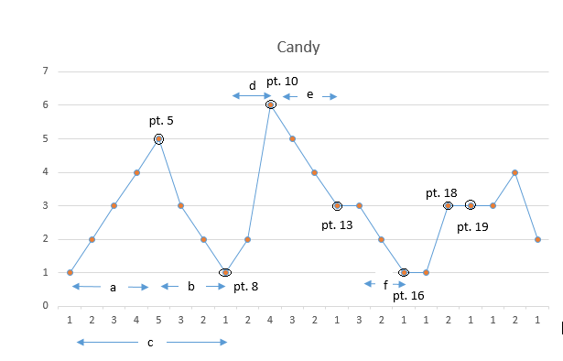

pt5是第一个波峰，pt8是第一座山的结束，在pt8时计算区域c的糖果数。上升区域4步，下降3步，因此pt5归属上升侧

$candy1=\frac{(4+1)*4}{2}+\frac{(3+1)*3}{2}+\text{max}(4,3)+1$

pt10是第二个波峰，上升2下降3, pt8多计算一次

$candy2=\frac{(2+1)*2}{2}+\frac{(3+1)*3}{2}+\text{max}(2,3)+1$

pt13到pt16是第三个，上升0，下降2, pt13多计算一次

$candy3=\frac{(0+1)*0}{2}+\frac{(2+1)*2}{2}+\text{max}(0,2)+1$

。。。